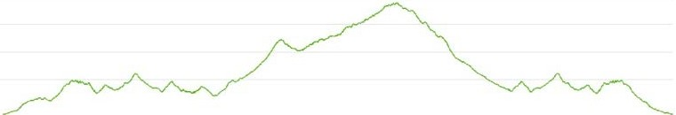
- ro.1
Elevation Map for 50 miler

