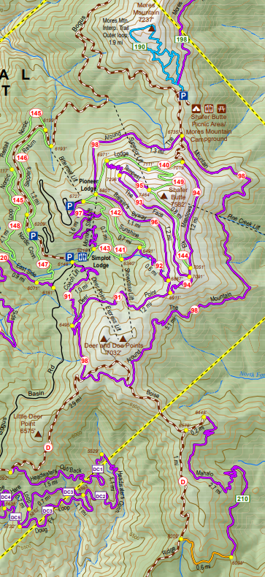

Aid

ATM 2nd Rd

Start

Finish.

Aid

ATM 4th Rd

**Resort to Rock**

**32k Course**